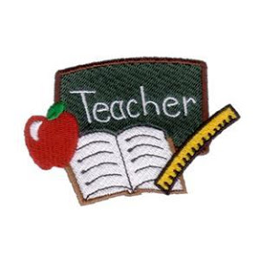
PERRY COUNTY RETIRED TEACHERS ASSOCIATION
SCHOLARSHIP RESPONSE
Name____________ Address_________________________________
Email______________ Home Phone__________ Cell Phone________
College____________ Year in College________ HS______________
Specific Major_____________________________________________
Background Information_____________________________________
_________________________________________________________
_________________________________________________________
Employment______________________________________________
________________________________________________________
Other Scholarships_________________________________________
Please attach your transcript and essay, “Why I choose to enter the field of education”. Or if a current teacher seeking a masters: “What has been your greatest accomplishment as a teacher?” Working on my Master’s in_________.
Note: All PC college students majoring in education and/or teachers working on a master’s in an educational field may apply; however, this year preference will be given to a Miller HS graduate (MHS teacher if no student application).
POSTMARKED: June 1ST Mail to: Betsy A. Martin, 10185 N State Rte. 60 NW, McConnelsville, OH 43756

